README – CRUD Python Module __Andre Miranda__

About the Project
This project implements the create, read, update, and delete components of a Python based CRUD module designed for the aac (animal adoption center) MongoDB database. The module provides a structured and reliable interface for adding new animal records and retrieving, updating, and deleting existing ones, ensuring safe and predictable behavior, and printing errors to the console while maintaining consistent interaction with the underlying collection.
A document-oriented database such as MongoDB is especially well suited for this domain because animal records often vary in structure where some animals may have medical notes, microchip IDs, or behavioral observations, while others may not. MongoDB’s flexible schema allows the module to store these variable fields without forcing rigid table structures or complex migrations. This flexibility mirrors real world shelter data, where incoming records rarely follow a uniform pattern.
The module’s architecture follows a modular, repository style design commonly used in production systems. By isolating database operations inside a dedicated class, the project ensures that future operations can be added without modifying existing logic. This separation supports long term maintainability, easier debugging, and cleaner integration with future applications such as dashboards, analytics tools, or web interfaces.

Motivation
The motivation behind this project is to create a clean, maintainable data access layer that supports secure authentication, predictable behavior, and scalable growth. In real software development, Create and Read operations form the foundation of any CRUD system, and validating operations early reduces risk before expanding into more complex functionality.
Using MongoDB for this project reflects a design choice where a document-based model naturally accommodates the variability of animal records that often differ in fields and depth of detail. This avoids the overhead of rigid relational schemas and allows the system to evolve as the shelter’s data needs change.
The module’s design also mirrors real world repository patterns, where database logic is encapsulated in a dedicated class rather than scattered throughout the application. This approach improves testability, supports future enhancements, and aligns with industry best practices for building scalable backend systems.

Getting Started
This module connects to a local MongoDB instance using the created credentials. The database (“aac”) and collection (“animals”) must already exist, and the authenticated user must have read/write permissions.

Project Structure
|── CRUD_Python_Module.py # Full CRUD class (Create, Read, Update, Delete)
|── ModuleFourTestScript.ipynb # Demonstrates full CRUD lifecycle across 3 records.
└── README.docx # Documentation for setup, usage, and reproduction

Database and Authentication Setup
- MongoDB must be running on “localhost:27017”.
- The “aac” database and “animals” collection must be created beforehand.
- A user with read/write permissions must exist in the “aac” database.
- Authentication uses the format:
“mongodb://<username>:<password>@localhost:27017/?authSource=aac”

MongoDB Import and Authentication Screenshots

The following screenshots document the initial database setup and authentication process completed in Codio. Includes:
-mongoimport command used to load the AAC dataset
-Successful import execution showing documents inserted
-Mongo shell user creation (db.createUser)
-Successful login using the authenticated user
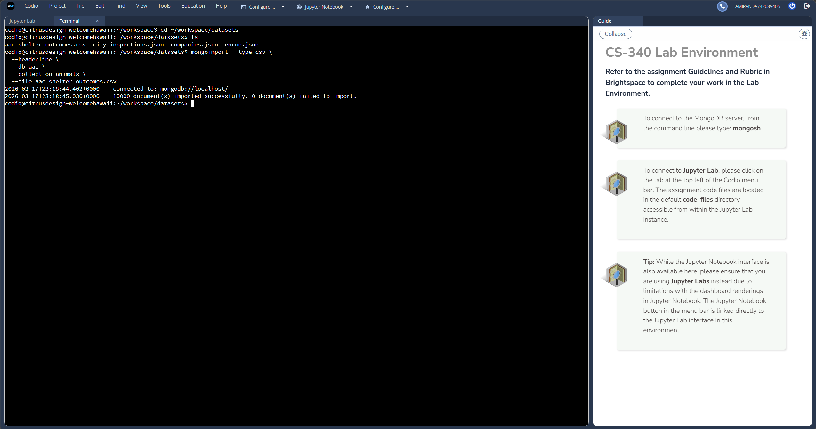
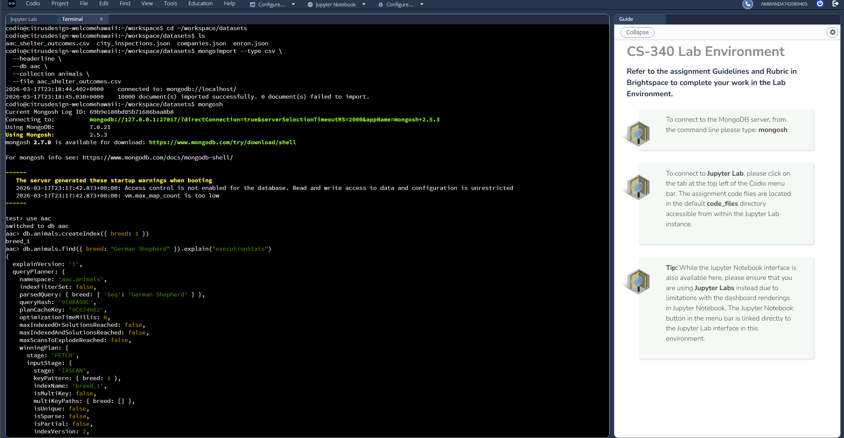
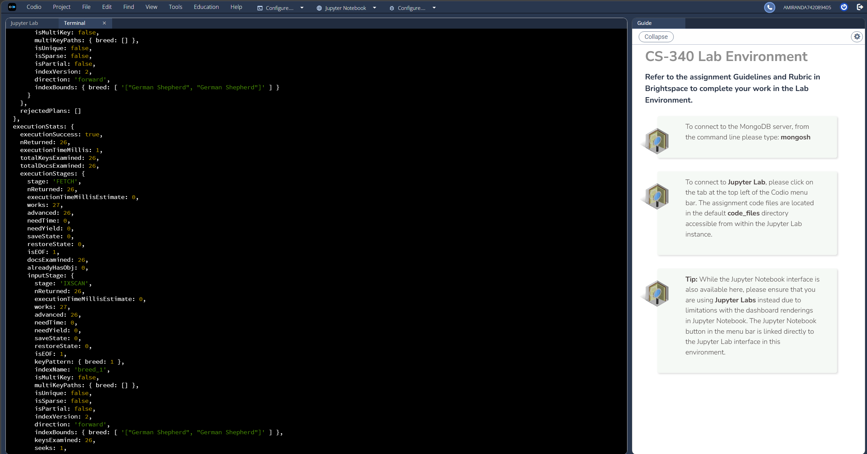
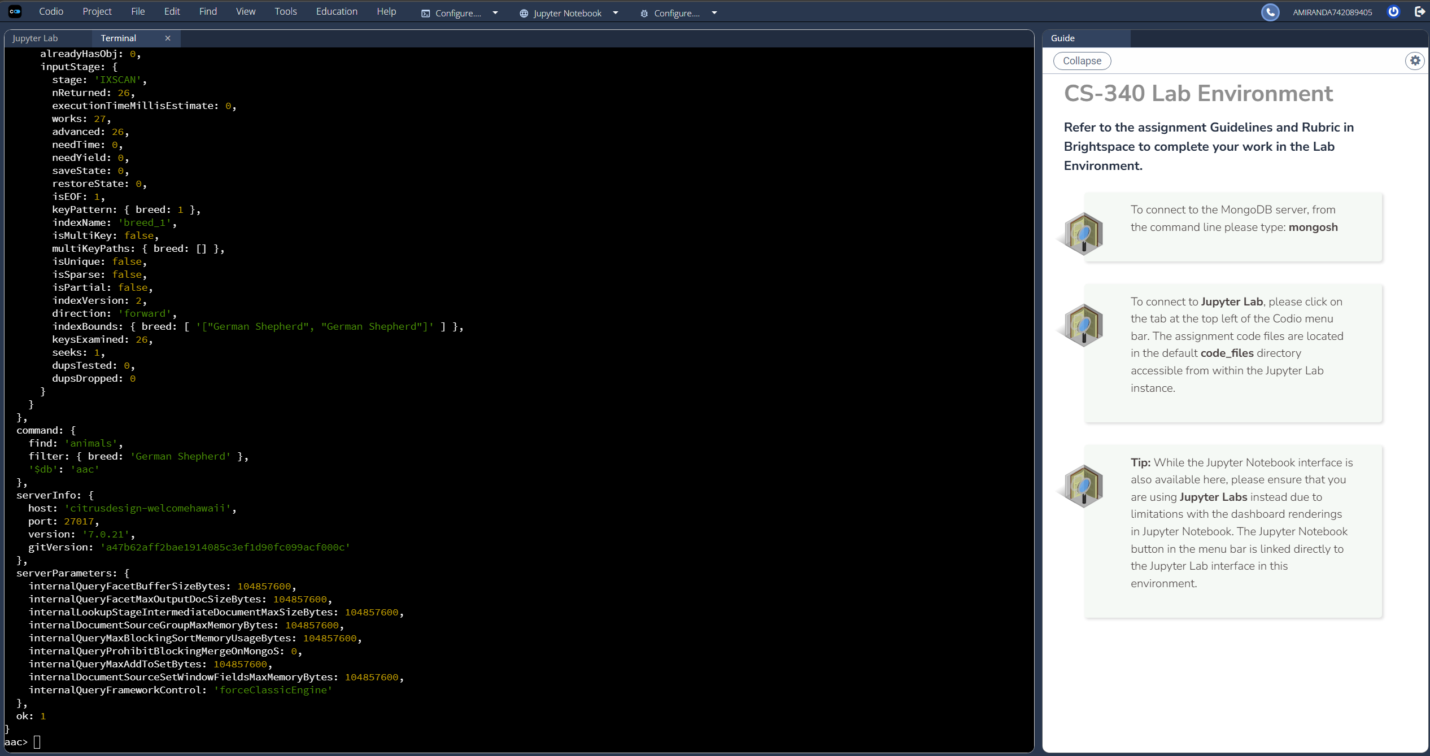
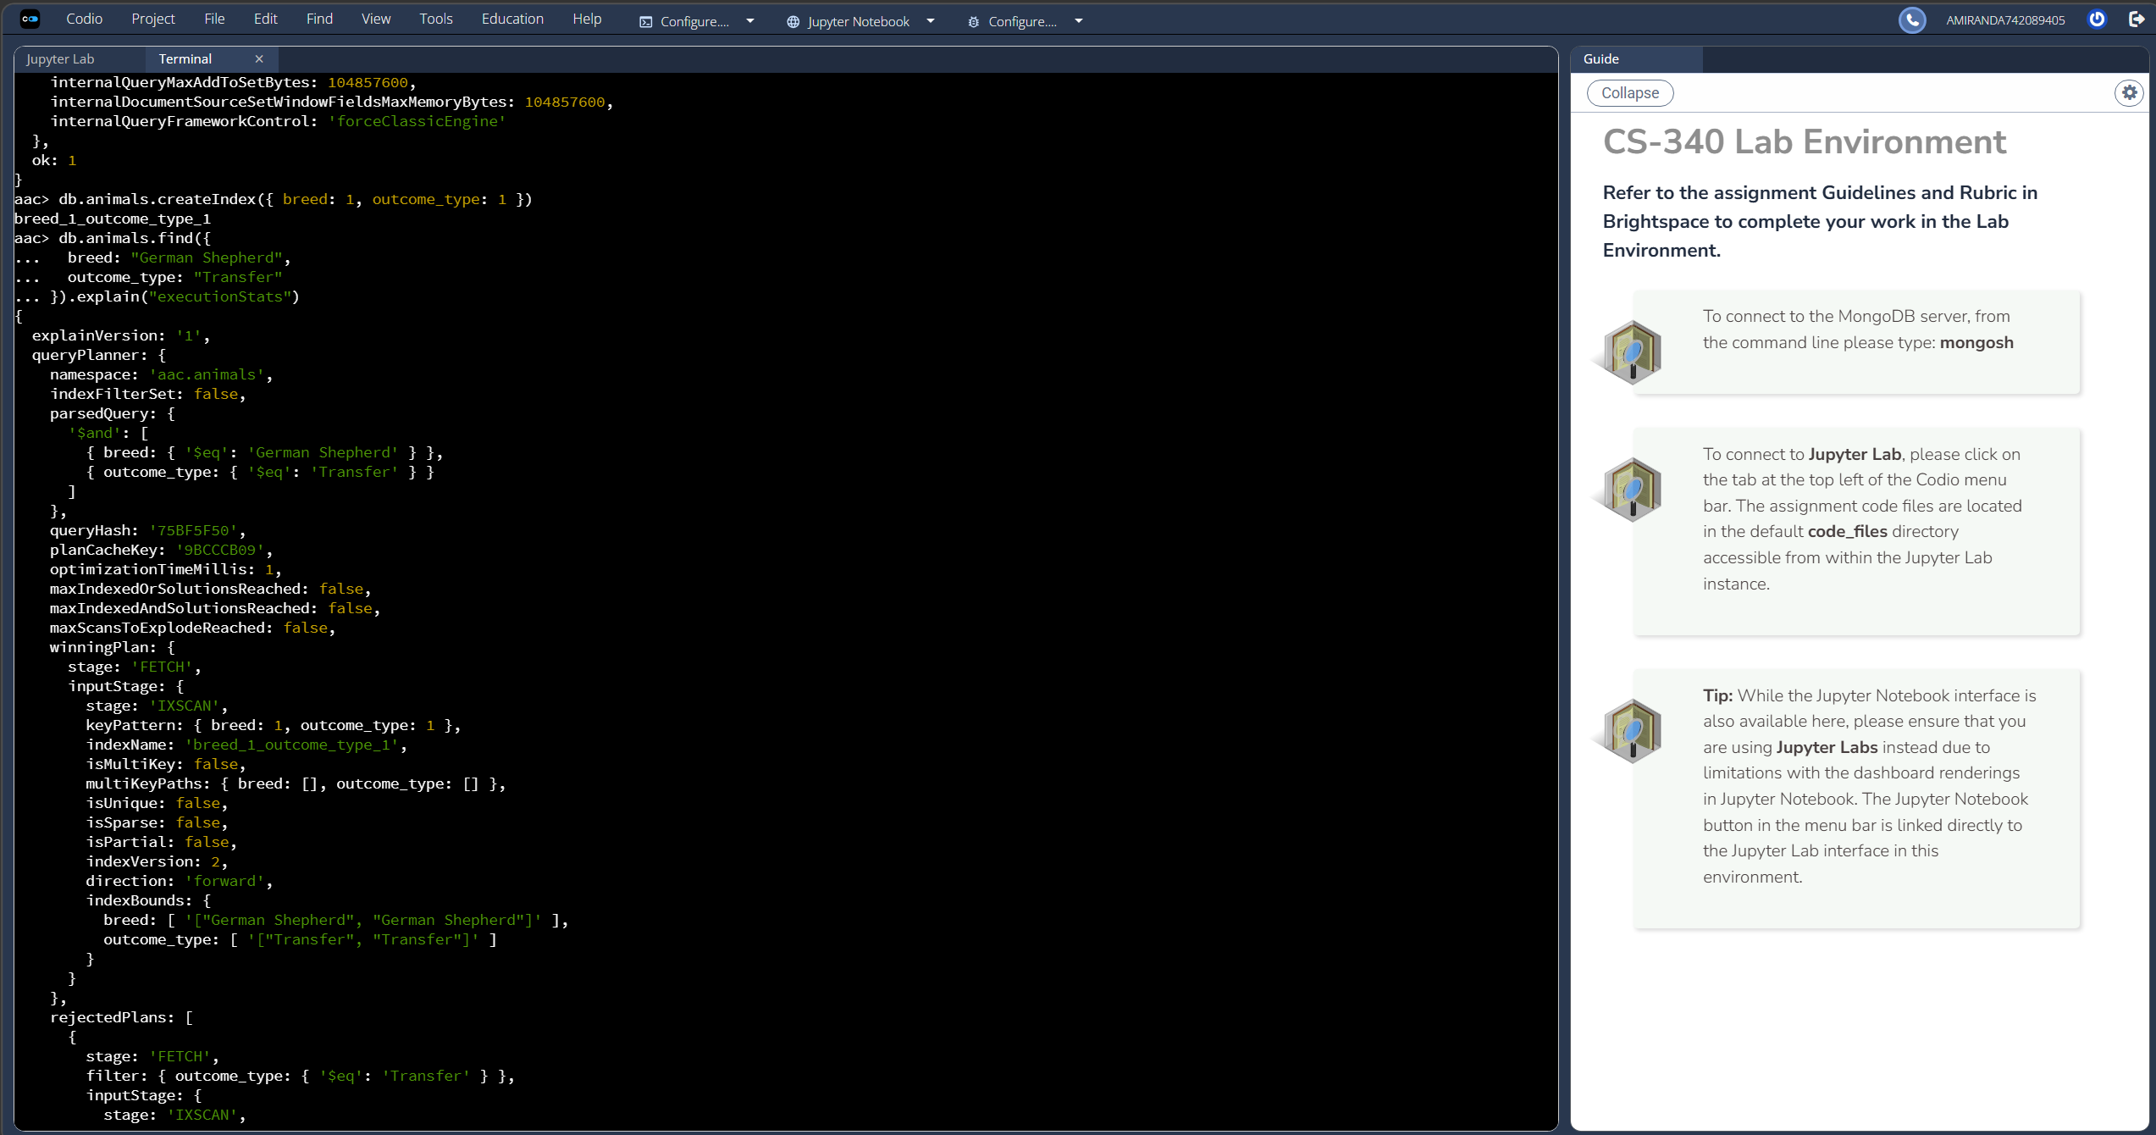
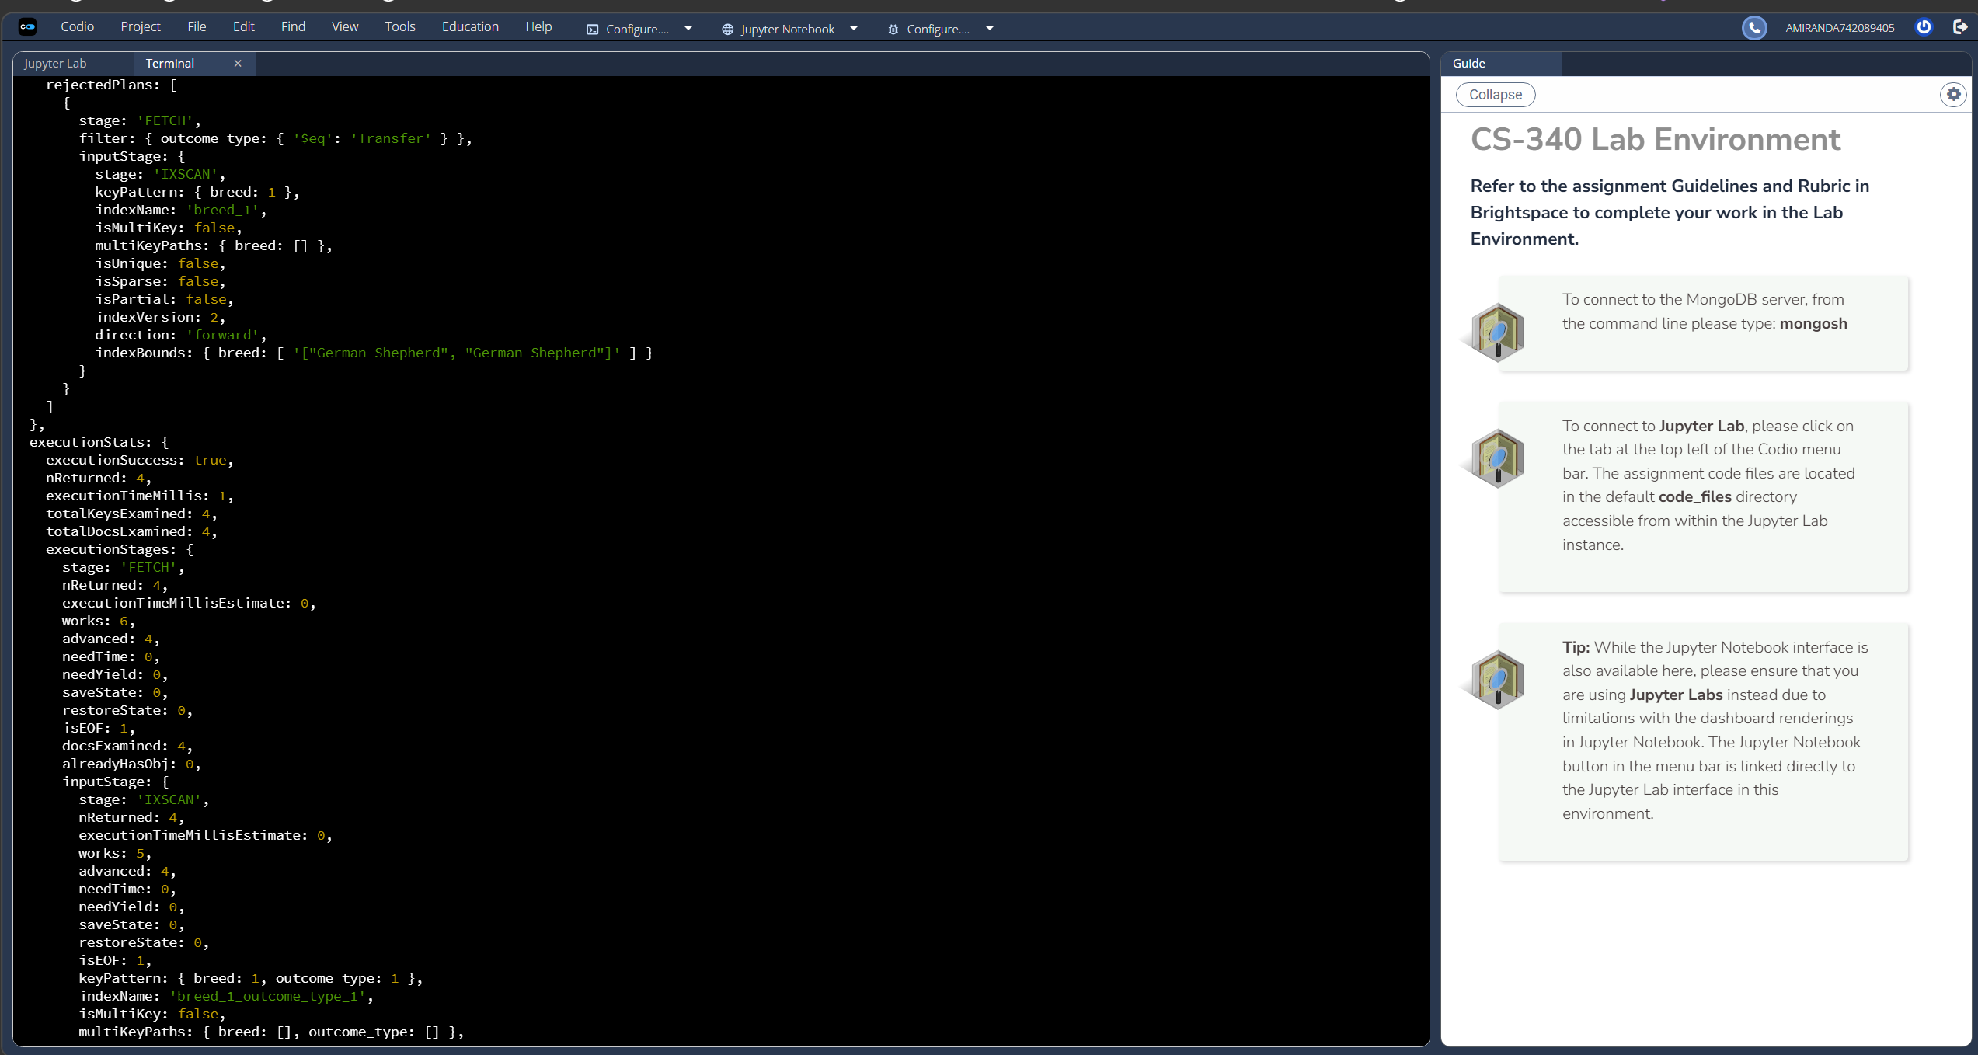
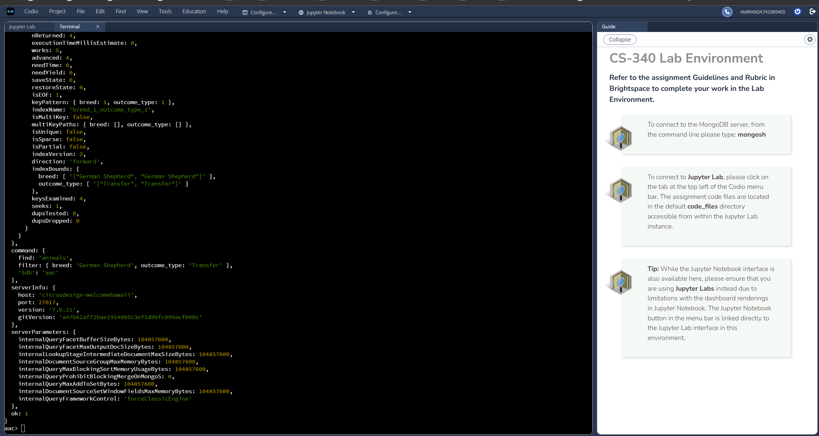
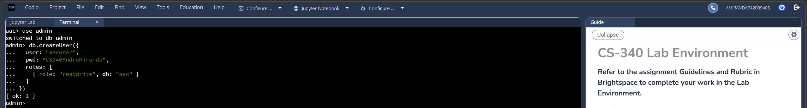
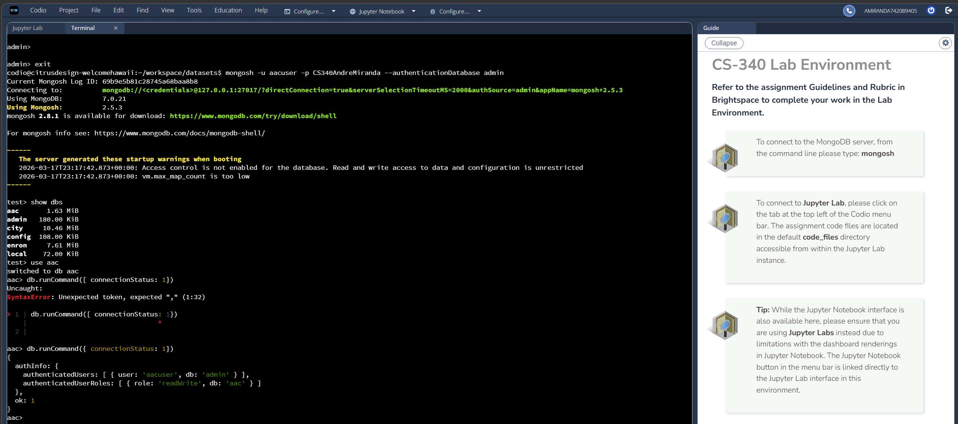

Codio Environment Notes
This project was completed in the Codio environment, which provides a preconfigured MongoDB instance. In Codio:
-MongoDB is already installed and running.
-The aac database and animals collection already exist.
-The aacuser account and password were created as part of the assignment.
-No manual installation or database/user creation is required.
-The connection string provided in the assignment must be used exactly as given.
-All testing is performed directly inside Codio’s terminal and/or the Jupyter notebook.

The rest of this README describes the general architecture and workflow of the CRUD module, which also applies to a local MongoDB setup.

Creating the CRUD Functions
The codebase implements all four CRUD operations using PyMongo’s official API. Each method includes input validation, exception handling, and predictable return values to ensure safe and consistent behavior.

- Create
Inserts a new document into the animals collection using insert_one().
Returns True if the insert is acknowledged, otherwise False.

- Read
Retrieves documents using find(), returning a list of matching records.
Using find() ensures consistent return types even when multiple documents match.

- Update
Modifies one or more documents using update_many() with the $set operator.
Returns the number of modified documents, allowing the caller to verify success.

- Delete
Removes one or more documents using delete_many().
Returns the number of deleted documents, confirming the operation’s effect.

These operations form the complete data access layer that will later support the Dash web application.

Security Enhancement
To ensure safe interaction with the AAC MongoDB database, the CRUD module includes several layers of defensive programming designed to prevent malformed queries, unauthorized operators, and unsafe update patterns. These safeguards help protect the database from accidental misuse and common injection style attacks.

Operator Blocking
MongoDB supports a variety of special operators (including: $where, $regex, $expr) that can alter query behavior or execute server-side logic. To prevent these operators from being used in queries or updates, the module explicitly rejects any field name beginning with the $ character except the safe operators (SAFE_OPERATORS = {"$in", "$gte", "$lte", "$gt", "$lt", "$eq", "$ne", "$regex", "$options"}):
-Blocks $where JavaScript execution
-“Allows $regex and $options only for controlled rescue filters”
-“Blocks all other operators beginning with $”
-Blocks $expr and other aggregation style operators
This ensures all queries remain simple, direct dictionary lookups and prevents both intentional and unintentional use of unsafe MongoDB features.

Field Whitelisting
The module restricts all queries and update operations to a predefined set of allowed fields:
ALLOWED_FIELDS = {
"name",
"animal_id",
"animal_type",
"breed",
"color",
"date_of_birth",
"datetime",
"monthyear",
"sex_upon_outcome",
"age_upon_outcome",
"age_upon_outcome_in_weeks",
"outcome_type",
"outcome_subtype",
"location_lat",
"location_long",
"notes",
"list_field",
"dict_field",
"numeric_field"
}
Any attempt to query or update fields outside this whitelist results in a validation error. This ensures:
-Only expected fields are used
-No accidental typos create new fields
-No user supplied input can manipulate the schema
-The database remains consistent and predictable

Empty Query Protection (read_all exception)
To prevent accidental mass updates or deletions, the module rejects empty dictionaries {} as valid queries. This ensures that:
-update_many({}) cannot modify the entire collection
-delete_many({}) cannot wipe all documents
-Every operation must explicitly target at least one field

Schema and Type Validation
The module enforces basic schema rules, including:
-Required “name” field
-“name” must be a string
-Inserted documents cannot be empty
-Update dictionaries cannot be empty
These checks ensure that all inserted and updated documents follow a predictable structure.
Together, these safeguards create a secure, injection‑resistant CRUD layer suitable for both academic and production style environments.

Installation
The following tools were used:

Python
Python was chosen for its readability, extensive standard library, and strong ecosystem of data handling tools. Its clear syntax makes the module easy to maintain, while its widespread use in backend development ensures compatibility with future extensions such as REST APIs and/or data analytics pipelines.

PyMongo
PyMongo serves as the official MongoDB driver for Python and provides a stable, well documented API for interacting with the database. It allows good control over queries, authentication, and error handling, making it ideal for building a custom CRUD module rather than relying on higher level abstractions that hide important database behavior.
Install with:
“pip install pymongo”

MongoDB Community Server
MongoDB Community Server was selected because its flexible document model aligns naturally with the structure of animal records, which often contain optional or irregular fields. Its JSON like storage format simplifies development and testing, and its local deployment makes it easy to reproduce the environment across different machines.

Usage
The module is designed to be imported into any Python script or Jupyter notebook that needs to interact with the aac MongoDB database. The testing workflow includes authentication validation, a failed login demonstration, and the complete CRUD lifecycle across three different record types.

Importing and Instantiating the Class
from CRUD_Python_Module import AnimalShelter

Authentication and Initialization
Before performing any database operations, the testing script first demonstrates a failed login attempt to confirm that the module correctly rejects invalid credentials:
print("---- TESTING FAILED LOGIN ATTEMPT ----")
try:
bad_shelter = AnimalShelter("incorrectuser", "incorrectpassword")
except Exception as e:
print("Failed Login Attempt:", e)

Successful Login
Next, the script performs a successful login using the valid AAC credentials:
print("\n---- INITIALIZING CRUD MODULE AND AUTHENTICATING ----")
shelter = AnimalShelter("aacuser", "CS340AndreMiranda")

Creating a Record
The first test inserts a standard, well‑structured animal record.
test_record = {
"name": "NotebookTestAnimal",
"animal_type": "Dog",
"breed": "TestBreed",
"age_upon_outcome": "3 years",
"outcome_type": "Adoption"
}

print("---- INSERTING STANDARD TEST RECORD ----")
create_result = shelter.create(test_record)
print("Create Result:", create_result)
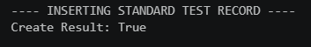

Reading a Record
print("\n---- READING STANDARD TEST RECORD ----")
query = {"name": "NotebookTestAnimal"}
read_results = shelter.read(query)
for doc in read_results:
print(doc)

Additional Test Cases
The testing script also included:
- A realistic animal record (“Sabrina Miranda”)
- An edge case record containing empty strings, empty lists, and None values
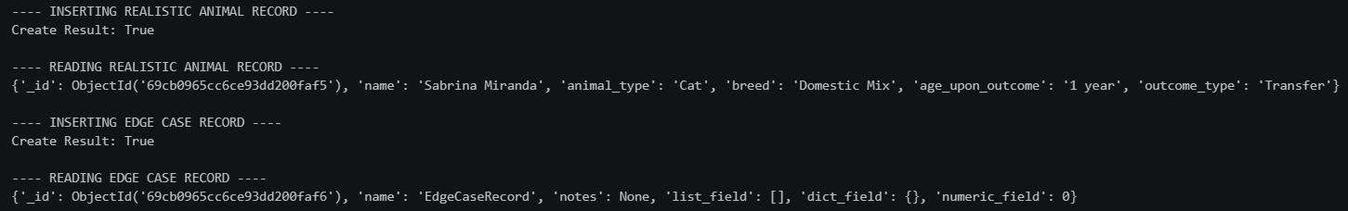
These confirm that the module handles both typical and unusual inputs without failing.

Updating a Record
print("\n---- UPDATING STANDARD TEST RECORD ----")
update_query = {"name": "NotebookTestAnimal"}
update_values = {"outcome_type": "UpdatedOutcome"}
update_result = shelter.update(update_query, update_values)
print("Documents Modified:", update_result)

print("\n---- READING UPDATED STANDARD TEST RECORD ----")
updated_docs = shelter.read(update_query)
for doc in updated_docs:
print(doc)
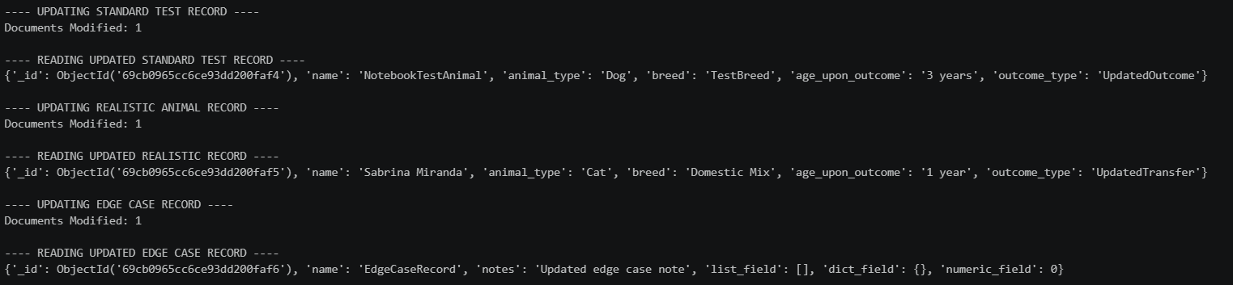

Deleting a Record and Deletion Verification
print("\n---- DELETING STANDARD TEST RECORD ----")
delete_query = {"name": "NotebookTestAnimal"}
delete_result = shelter.delete(delete_query)
print("Documents Deleted:", delete_result)

print("\n---- VERIFYING DELETION ----")
verify_docs = shelter.read(delete_query)
print("Remaining Documents:", verify_docs)
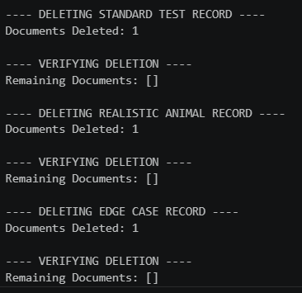

Test Output Screenshots
The following screenshots demonstrate a failed login attempt, a successful login attempt, connection to the database, and the full CRUD lifecycle for all three test records used in ModuleFourTestScript.ipynb.
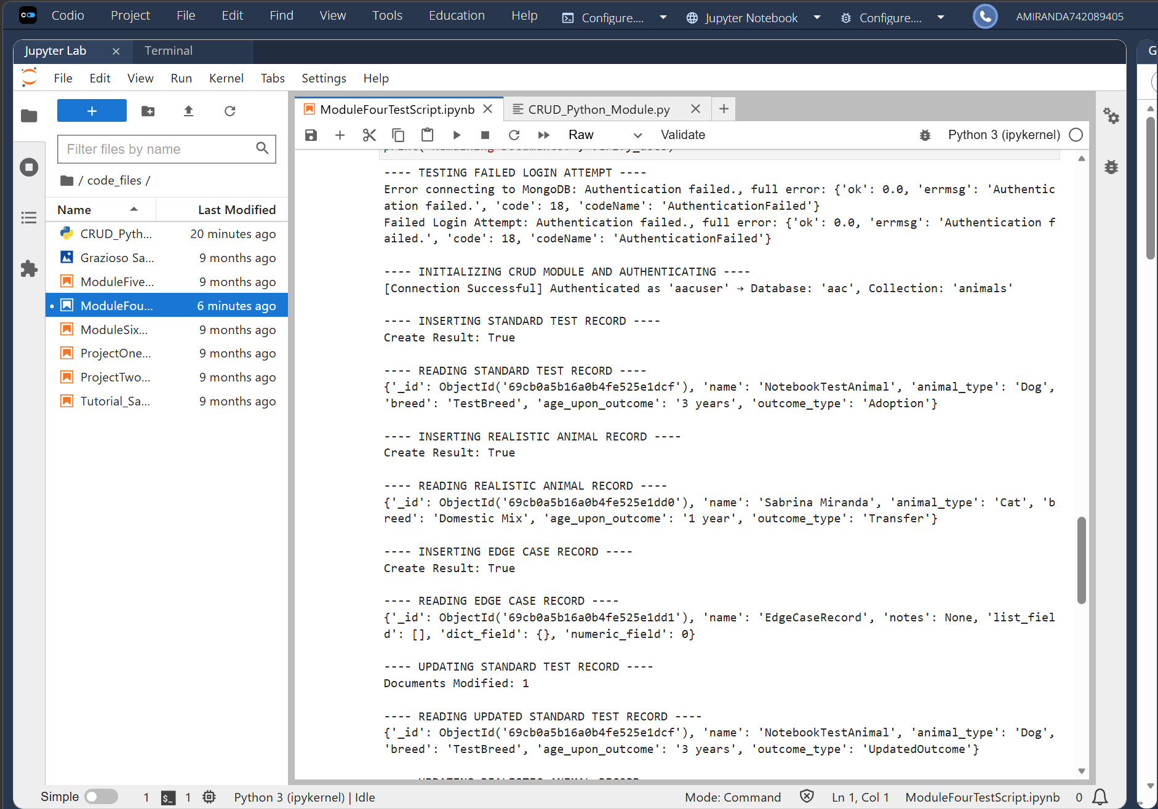
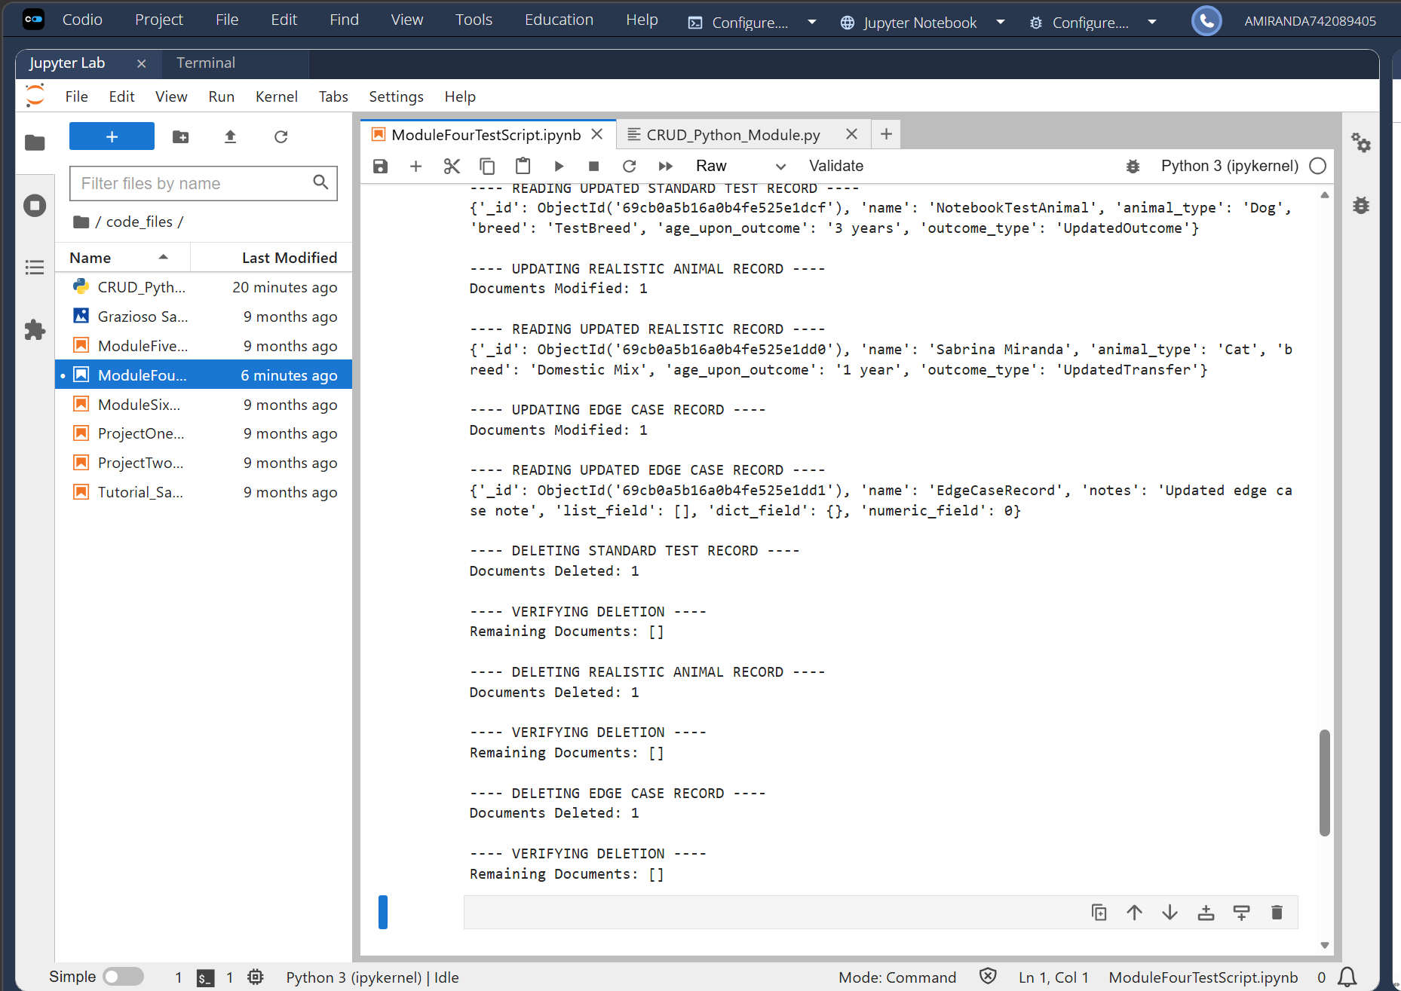

Reproducing the Project
Reproducing the Project

The following steps ensure that any user can recreate the environment, authenticate successfully, and run the same full CRUD lifecycle demonstrated in this project.

1. Install MongoDB Community Server and start the service.
MongoDB must be running locally for the module to establish a connection.

2. Create the aac database and animals collection.
These must exist before running the CRUD module.

3. Create a user with read/write permissions in the aac database.
Authentication in MongoDB is database‑scoped; creating the user in admin will cause login failures.

4. Install Python and PyMongo.
PyMongo is required for all database operations.

5. Place the CRUD module file and testing script in the same directory.
This ensures the import statement is resolved correctly.

6. Update the username and password in the testing script if needed.
Incorrect credentials will prevent authentication.

7. Run ModuleFourTestScript.ipynb.
Successful Create, Read, Update, and Delete operations confirm that the environment is configured correctly.

Steps to Reproduce
-Install MongoDB Community Server and start the service.
--MongoDB must be running locally for the module to establish a connection. Forgetting to start the service is the most common cause of connection errors.
-Create the “aac” database and “animals” collection.
--The module does not create these automatically, so they must exist beforehand to avoid “namespace not found” errors.
-Create a user with read/write permissions in the “aac” database.
--Authentication in MongoDB is database scoped, so creating the user in the wrong database (admin for example) will cause login failures.
-Install Python and PyMongo.
--PyMongo is required for all database operations and missing this dependency will result in import errors.
-Place the CRUD module file and testing script in the same directory.
--This ensures the import statement (from CRUD_Python_Module import AnimalShelter) resolves correctly.
-Update the username and password in the testing script if needed.
--Incorrect credentials are another common source of connection failures.
-Run the testing script to verify login and CRUD functionality.
--Successful insertion, retrieval, update, and deletion confirm that authentication, database setup, and module logic are all functioning correctly.

Common Mistakes and How to Avoid Them
-MongoDB service is not running: Always verify the service is active before testing.
-User created in the wrong database: Ensure the user is created inside the aac database, not admin.
-Incorrect authentication URI: The authSource=aac parameter is required for proper authentication.
-Missing dependencies: Install PyMongo before running the script.

Reflection on Challenges and Solution
Developing the full CRUD module required handling of variable data structures, error management, and predictable return behavior. Ensuring that each method failed safely and consistently was essential for building a reliable data access layer. Testing across three different data shapes confirmed that the module performs reliably under diverse conditions. This level of validation ensures that the module is ready for integration with the Dash web application.

